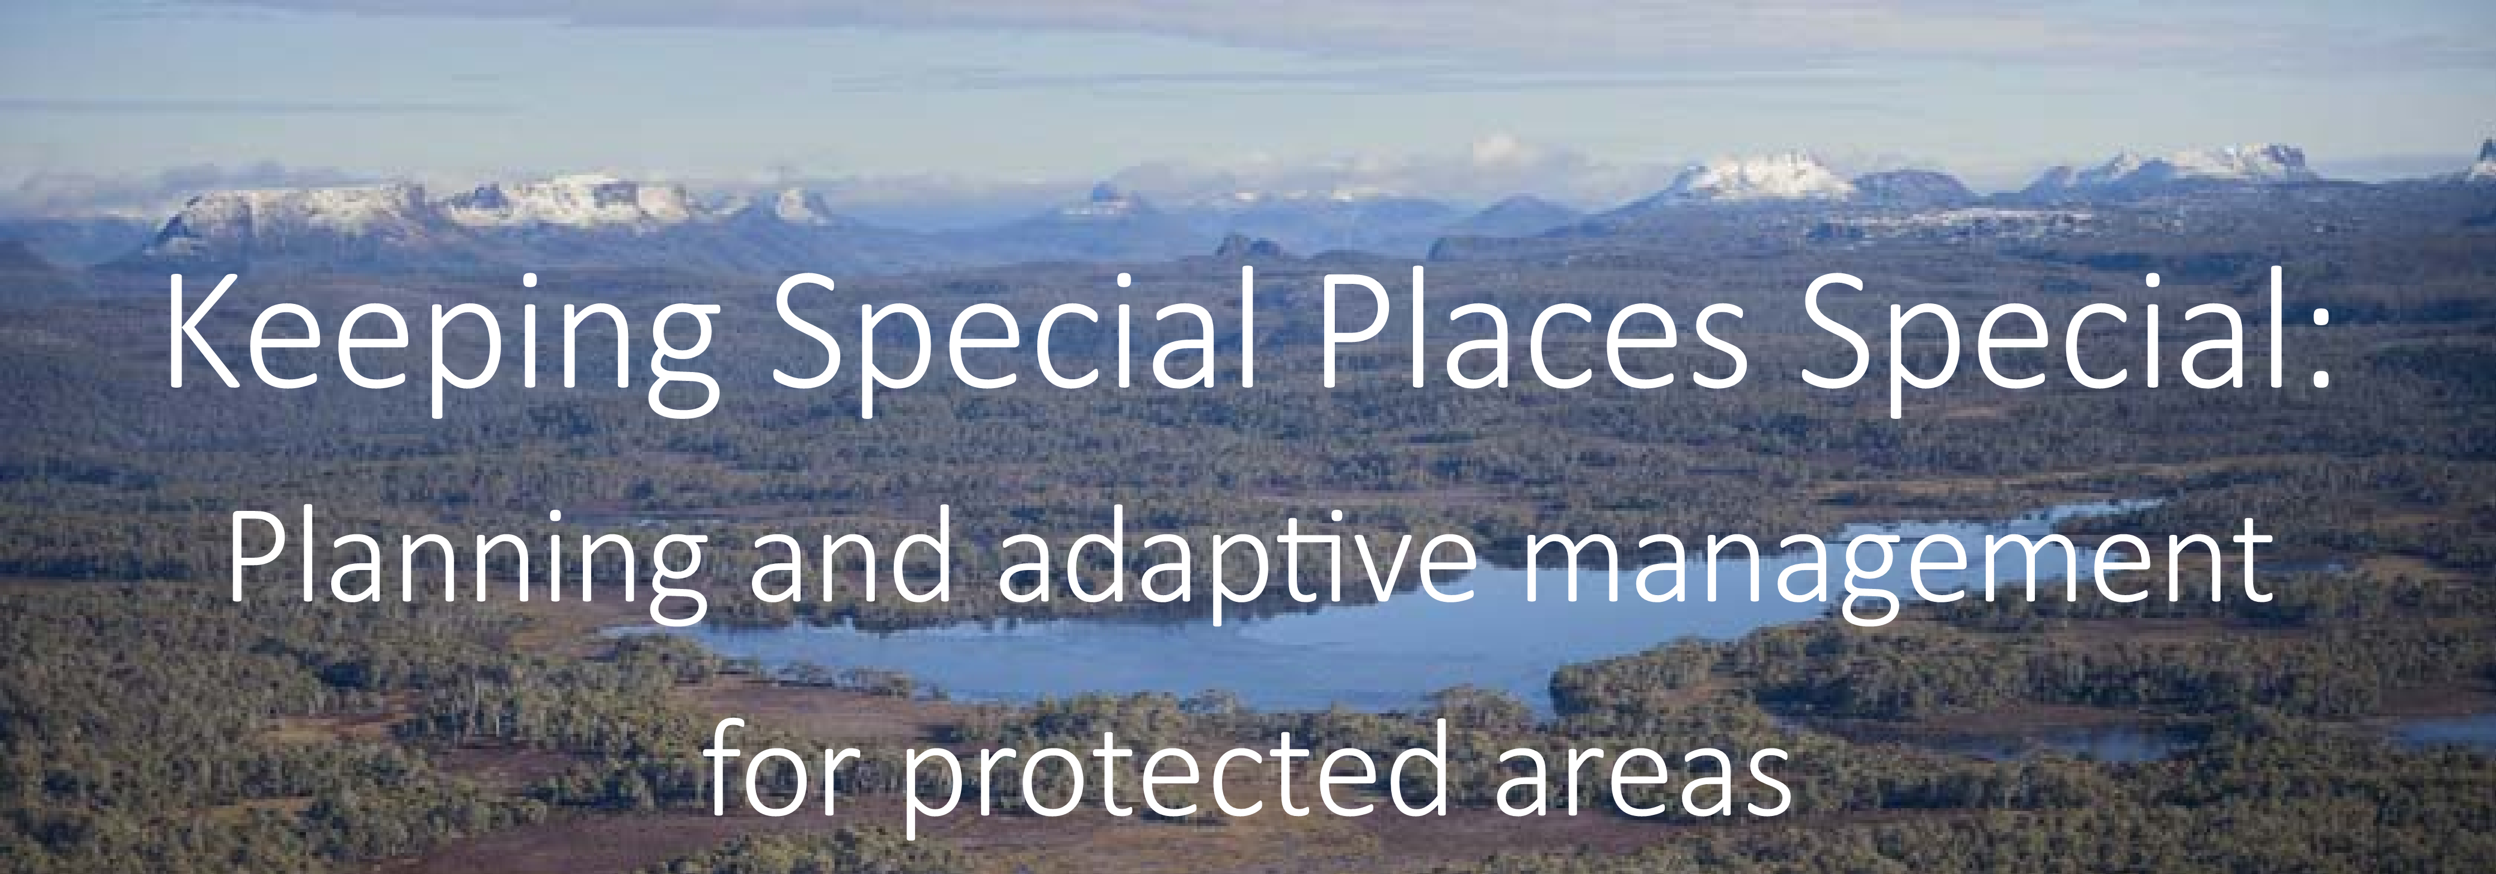
Workshop Agenda

Aims

The aim of this workshop is to introduce you to the Healthy Country Planning/Open Standards process, in particular, the details of steps that differentiate the Open Standards from other planning processes. It includes:

- Overview of preplanning and setting the scene, understanding the situation
  - Choosing Targets and defining their nature and health - Viability
  - Defining Threats and understanding the factors behind them
  - Conducting a Situation Analysis in preparation for developing the plan
- Making the Plan
  - Setting Goals and Objectives
  - Strategies and evaluating their priority
  - Results chains to test your understanding
  - Measures and monitoring
- Plan Review:– “Closing the Circle”

- Review support materials (e.g. PowerPoint presentations; guidelines; “tools”; website, etc.)

We are also aiming to expand the circle of practitioners.

MONDAY |  | FACILITATOR
9:00 | Meet at UTas, depart 0930
12 midday | Arrive Bronte Park - settle in / lunch
1:00 | Welcome. Purpose & objectives for course  - Review objectives, agenda, logistics  - Background material, notebooks and homework | DS
1:20 | Participant introductions – Everyone  Team setup  Round the room  Allocate people to their teams | AH
2:00 | Introduction to Open Standards.  (Presentation: overview of the process)  Include guidance on things to listen for from the expert presenters | DS
3.00 | BREAK
3:30 | Overview of the Five Rivers / trawtha mukaminya  Overview of the Five Rivers Project and properties (ecological, cultural and social perspectives) | DS / DK
5.30 | + /  BREAK / DINNER
7:30 | SESSION 1: Pre-planning – people, places, process, language  - Understanding the purpose of planning process  - Establishing clear roles and responsibilities  - Understanding capacity  Presentation, Tools to use | DS
7.45 | SESSION 1: Project Scope & Vision  - Presentation of the Step  - Results/outputs from this step (how has it been used and adapted)? | AH
8:00 | Exercise Pre-planning, Vision and Scope | AH
9:30 | CLOSE

TUESDAY |  | FACILITATOR
7:00 am | Breakfast
8.00 AM | Field trip  - Bus tour of the Five Rivers and trawtha mukaminya  - Discuss with the expert presenters your vision and scope  - Discuss targets, threats that have been presented  - See issues and scale first hand | DS / DK
11.00 | BREAK
11.15 | SESSION 2: Targets - Landscape, Livelihood, Cultural, Bio-cultural, Language– What are we trying to manage?  - Presentation of the Step  - Introduction of tools that can be used  - Results/outputs from this step (how used and adapted)? | AH
11.50 | Exercise: Each team to develop at least two targets (biophysical and social / cultural) for their project using the steps and tools provided. Followed by Facilitated feedback session. | AH
1.00 | LUNCH
1.30 | SESSION 2: Target Viability (Health). How healthy are the Targets?- Identifying attributes of targets and their indicators; using these to rate overall Target Viability  - Presentation of the Step  - Introduction of tools that can be used  - Results/outputs from this step (how has it been used and adapted)? | DS
 | Exercise: Each team to develop attributes, indicators and ratings for at least one of their project’s biophysical targets using the steps and tools provided. Followed by Facilitated feedback session. | DS
3:30 | BREAK
3:40 | SESSION 3: Threats (Problems and causes) – What is impacting on our Targets? Identify Stresses to Targets and their Sources; Rank the Threats  - Presentation of the Step  - Introduction of tools that can be used  - Results/outputs from this step (how has it been used and adapted)?  Demonstration example | AH
 | Exercise: Each team to develop Threats (Stresses and Sources) and rank them for at least one of their Targets.  Followed by Facilitated feedback session. | AH
5.30 | + /  BREAK / DINNER
7:30 | Team presentations of initial scope targets threats | DS
9:30 | CLOSE

WEDNESDAY |  | FACILITATOR
7.00 | Breakfast
8.15 | Review Day 2: targets and viability, viability table, threats and threat ranking | DS
8.30 | SESSION 4: Introduction to Situation Analysis – What is driving the threats and who are the stakeholders? Using a Situation Analysis or Conceptual Model to understand the context and opportunities.  - Presentation of the Step  - Introduction of tools that can be used  - Results/outputs from this step (how has it been used and adapted)? | AH
9.00 | Exercise: Each team to develop a Situation Analysis for at least one of their Targets. Followed by Facilitated feedback session. | AH
10.30 | BREAK
1100am | SESSION 5: Develop Goals and Objectives: What should we focus on? What are we trying to achieve?  - Presentation of the Step  - Introduction of tools that can be used  Results/outputs from this step (how has it been used and adapted)? | DS
11.20 am | Exercise: Teams to develop goals and objectives Followed by Facilitated feedback session | DS
12:30 pm | LUNCH
1.30 | SESSION 6: Strategies and Strategy Evaluation: How are we going to meet our goals? Which strategies should we focus on?  - Presentation of the Step  - Introduction of tools that can be used  - Results/outputs from this step (how has it been used and adapted)?  Demonstration example | AH
1:50 pm | Exercise: Each team to develop fully and evaluate at least two strategies to meet the objectives for their project using the tools provided. Followed by Facilitated feedback session. | AH
3.00pm | BREAK
3.30pm | SESSION 7: Results Chains: Developing a Theory of Change/Program Logic - Do our strategies really help us get to our Goal? What will we measure / how will we know?  - Presentation of the Step  - Introduction of tools that can be used  - Results/outputs from this step (how has it been used and adapted)? | DS
3.50 pm | Exercise: Each team to develop at least one results chain to meet an objective for their project using the tools provided. Followed by Facilitated feedback session. | DS
5.30 pm | + /  BREAK / DINNER
7:30pm | Evening session to finish off steps from earlier in the workshop  Preparing for evaluation | AH
9:30 pm | CLOSE

THURSDAY
7:00 am | Breakfast
 | Review
8.15 | SESSION 8: Measures and Monitoring – What will we measure, when, and why? What are the indicators and how will we measure them? Identifying audiences and information needs.  - Presentation of the Step  - Introduction of tools that can be used  - Results/outputs from this step (how has it been used and adapted)? | DS
8.30 | - Exercise: Each team to develop a monitoring plan using their result chains | DS
10.00 | BREAK
10.15 | SESSION 9: Implementation  Q&A Session with TLC reserve managers in the field  Challenges with implementation  Could just be a break in the bush
12.00 pm | LUNCH
12.45 | SESSION 10: Operational plans: Actions, timing and budgets:  • Presentation of the Steps  • Introduction of tools that can be used  • Results/outputs from this step (how has it been used and adapted)? | AH
1.00pm | - Exercise: Each team to develop a work plan using their result chains | AH
2.00 | SESSION 11: Analyze, Review and adapt: reviewing the Plan, creating a culture of review.  - Presentation of the Step  - Introduction of tools that can be used  - Results/outputs from this step (how has it been used and adapted)? | DS
2.15 | Exercise: Teams develop a proposed process for ensuring regular review and adaptation of the plan to complete the cycle. | DS
3.30 pm | BREAK
3.45 | SESSION 12: Putting it all together: Understanding funding and capacity requirements; Refining the budget; Assessing project level risks.  Linking all the steps; Collating and presenting the plan  • Presentation of the Steps  • Introduction of tools that can be used  • Results/outputs from this step (how has it been used and adapted)? | DS
4.00 | Exercise: - Each team to develop communication plan outlining how they will communicate the plan / workplan | DS
5.00 pm | Resources and Support: CCNET, Miradi, ConPro etc  Review and Evaluation of the workshop | DS
5.30 | + /  BREAK / DINNER
7.30 pm | Team preparation of materials for Assessment
9:30 pm | CLOSE

FRIDAY
7:00 am | Breakfast
9.00 | SESSION 13: Presentation of Plans  Each team to present a 30 minute PPT of their plan
10.00 | BREAK
10.30 | SESSION 13 (cont): Presentation of Plans  Each team to present a 30 minute PPT of their plan
11.30 | Wrap up, evaluation, pack up
12.00 pm | LUNCH
1.00 | Leave Bronte Park
4.00 | Arrive Hobart

