Protected Areas Learning and Research Collaboration
Open Standards Short Course

EXERCISE: CREATING A MONITORING PLAN
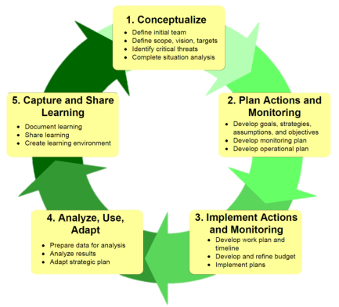
Why should you do this step
- To have a clear plan about what you need to monitor, when, who will do it, and what you will do with the results.

- Monitoring takes time and resources, and can waste a lot of both –time spent now writing a monitoring plan as part of the overall plan can save a lot of time and money
Summary: Participants will work in their teams to develop a simple Measures Plan, using their results chains and other materials developed in the workshop.
- Develop one or more indicators for each goal, objective and other information needs
  - A good indicator should meet the following criteria:
    - Measurable: Able to be recorded and analyzed in quantitative or qualitative terms.
    - Precise: Defined the same way by all people.
    - Consistent: Not changing over time so that it always provides comparable measurements.
    - Sensitive: Changing proportionately in response to actual changes in the condition or item being measured.
- Look across your Results Chain and identify the points where an indicator would be most critical to demonstrate the causal links in the chain - focusing on those ‘if-then’ steps with greatest uncertainty. Record the indicator and place it below the result.
- Further prioritize your indicators based on your monitoring budget - which indicators are high priority and why.
- For priority indicators, select your methods and how you will collect the information
  - A good method should meet the following criteria:
    - Accurate: Gives minimal or no error
    - Reliable: Results obtained using the method are consistently repeatable
    - Cost-effective: Not overly expensive for the data the method yields or for the resources the project has
    - Feasible: Project team has people who can use the method, as well as the material and financial resources to use the method
    - Appropriate: Appropriate to the environmental, cultural, and political context of the project
- Determine who will collect the data and when
- How are the results to be used and disseminated?
- What changes could result from the information?
Using the tables below as a guide for your butchers paper, develop a plan to review:
Implementation of Actions (Strategies and Actions on the Results chain)
Action | Method | Frequency | Who | Cost | Source of Funds | What happens to result | What changes?

Effectiveness of your Strategies (Intermediate outcomes / Objectives on the Results chain)
Indicator | Method | Frequency | Who | Cost | Source of Funds | What happens to result | What changes?

Status of your Targets (Objectives and Goals on the results chain, Indicators in the Attribute Table)
Indicator | Method | Frequency | Who | Cost | Source of Funds | What happens to result | What changes?
