Exercise: Threat Assessment

SUMMARY: This exercise is about keeping it simple and minimizing the number of steps to get to the completion of a rough first cut of a targets and threats table – bit like speed dating for targets and threats.
OBJECTIVE(S): To identify and prioritise the threats affecting the Targets (Things we care about)
INSTRUCTIONS: In this exercise operate in groups and develop and rank the threats to your targets to complete the threats table for your project area.

Step 1: For each target brainstorm the problems that might impact on the health of the target. Use cards or flip charts (cards are easier to move around)

HINT: Problems will be things that are closely linked to the indicators of health eg loss of population, reduced water quality, damage to sites
Step 2. For each target, then brainstorm the causes of the problems. The causes are then your threats.

HINT: Causes are the direct things that make the problem happen eg feral animals cause a loss of water quality; cats cause a loss of population of native animals

Step 3. Put the threats and the targets into a table like this one.

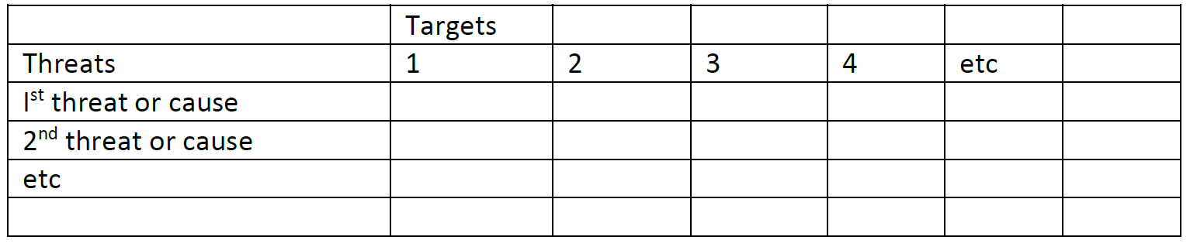
- Rank threats using table in workbook to decide: Amount of damage / How badly damaged / Fixable scores;
- Use Ranking guideline to assign category (very high, high, medium, low) to each of the individual threat/target-links

Ranking Guidelines
 | How Badly Damaged – how much damage will happen in the next 10 years if things don’t change
 | Very High | 4- The threat is likely to destroy or eliminate some part of the target in the project area
 | High | 3- The threat is likely to seriously damage some part of the target in the project area
 | Medium | 2 - The threat is likely to moderately harm some part of the target in the project area
 | Low | 1- The threat is likely to only slightly harm some part of the target in the project area
 | Amount of Damage – how much of the target will be damaged in the next 10 years if things don’t change
 | Very High | 4 -The threat is likely to be very widespread, and affect the target wherever it is in the project area
 | High | 3 -The threat is likely to be widespread, and affect the target at many places at in the project area
 | Medium | 2 - The threat is likely to be more local, and affect the target at some places in the project area
 | Low | 1 -The threat is likely to be very local, and only affect the target at a very few places in the project area

 | Fixable – Can the problem this cause creates be fixed?
 | Very High | 4 - The cause produces a problem that is not fixable (e.g. wetland converted to shopping center)
 | High | 3 - The cause produces a problem that is fixable, but really expensive (e.g. wetland converted to agriculture)
 | Medium | 2 - The cause produces a problem that is fixable with a reasonable commitment of additional resources (e.g. ditching and draining of wetland)
 | Low | 1 - The cause produces a problem that is easily fixable at relatively low cost (e.g. recreational vehicles trespassing in wetland)

Ranking Guidelines

Rank | Score
Low | 1 - 12
Medium | 13 - 24
High | 25 - 36
Very High | 36 - 64

Example for Northern Australia Savanna in the Northern Territory (Step 1)
 | Targets
Threats | Monsoon vine thicket | Savanna Woodland | Limestone springs | Wetlands | Bush Foods (plants) | Bush Foods (Animals) | Threatened Animals | Cultural sites | Average
1. Wild Fire | 4 x 4 x 3 | 4 x 4 x 3 |  |  | 4 x 4 x 3 | 3 x 4 x 3 | 2 x 4 x 3 | 2 x 4 x 3
2. Large feral herbivores (Buffalo, cattle, horses, donkeys) | 3 x 4 x 2 | 3 x 4 x 2 | 3 x 4 x 3 | 4 x 4 x 3 | 4 x 4 x 3 | 1 x 4 x 3 | 2 x 4 x 3
3. Smaller feral animals (pigs) | 2 x 4 x 2 | 2 x 4 x 2 | 2 x 4 x 2 | 2 x 4 x 2 | 3 x 4 x 2 | 3 x 4 x 2 | 2 x 4 x 2
4. Cane toads |  |  | 2 x 4 x 4 | 2 x 4 x 4 |  | 3 x 4 x 4 | 1 x 4 x 4
5. Cats
6. Invasive grassy weeds | 2 x 4 x 2 | 2 x 4 x 2 | 2 x 4 x 2 | 2 x 4 x 2 | 3 x 4 x 2
7. Mining | 1 x 4 x 4 | 1 x 4 x 4 |  |  | 1 x 4 x 4
8. Roading | 1 x 4 x 4 | 1 x 4 x 4
9. Pig Shooters |  |  |  |  |  |  |  | 2 x 4 x 4
10. Toursim |  |  |  |  |  |  |  | 2 x 4 x 4

Example for Northern Australia Savanna in the Northern Territory (Step 2)

 | Targets
Threats | Monsoon vine thicket | Savanna Woodland | Limestone springs | Wetlands | Bush Foods (plants) | Bush Foods (Animals) | Threatened Animals | Cultural sites | Average | RANK
1. Wild Fire | 48 | 48 |  |  | 48 | 36 | 24 | 24 | 38 | VERY HIGH
4. Cane toads |  |  | 32 | 32 |  | 48 | 16 |  | 32 | HIGH
9. Pig Shooters |  |  |  |  |  |  |  | 32 | 32 | HIGH
10. Tourism |  |  |  |  |  |  |  | 32 | 32 | HIGH
2. Large feral herbivores (Buffalo, cattle, horses, donkeys) | 24 | 24 | 36 | 48 | 48 | 12 | 24 |  | 31 | HIGH
3. Smaller feral animals (pigs) | 16 | 16 | 16 | 16 | 24 | 24 | 16 |  | 18 | MEDIUM
6. Invasive grassy weeds | 16 | 16 | 16 | 16 | 24 |  |  |  | 18 | MEDIUM
7. Mining | 16 | 16 |  |  | 16 |  |  |  | 16 | MEDIUM
8. Roading | 16 | 16 |  |  |  |  |  |  | 16 | MEDIUM
5. Cats

