Exercise: Strategy Development & Ranking

Summary: Each group will evaluate at least two strategies; and look at strengths and weaknesses of these strategies. This approach can be used to compare strategies and help decide which ones to select for the plan.
STEP 1
- Choose one of your Goals
- Look at your Situation diagram and talk about (brainstorm) all the different strategies (actions to improve targets or reduce threats) to achieve the Goal.
- Write the strategies on yellow sticky notes and place them on the diagram
- When you have done this for one Goal, pick another and do it again.

STEP 2
- Select just one of the strategies. Use the table provided below and look at the list of criteria for Feasibility and Impact, which will help you think about and give a score to each strategy.
- The overall score will then be used to compare, and rank, each strategy.
- Repeat this process for as many strategies as you can.

STEP 3
- Consider the results:
- Were they what you expected?
- Did you identify any weaknesses in your strategy? If so, consider whether the strategy can be improved.
- Are there any strategies that appear to be really strong against these criteria.
- Select strategies for your plan based on this assessment i.e. which strategies ranked highest
- You might also think about other things such as the current capacity of the project team, current funding sources etc.

STRATEGY EVALUATION using a simple scale
STRATEGY | IMPACT (next page for ranks) | FEASIBILTY (next page for ranks) | Overall Rank (table below)

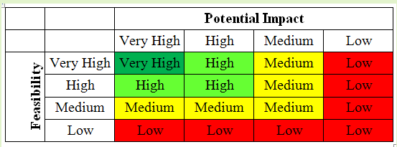
    - Potential Impact – Degree to which the strategy (if implemented) will lead to desired changes in the situation within the scope of your project
- Very High – completely mitigate a threat or restore a target.
- High – help mitigate a threat or restore a target.
- Medium – possibly help mitigate a threat or restore a target.
- Low –probably not contribute to meaningful threat mitigation or target restoration.

    - Feasibility – Degree to which your project team could implement the strategy within likely ethical, financial/staffing, and technical/time constraints
- Very High – ethically, technically, AND financially feasible.
- High – ethically and technically feasible, but may require some additional financial resources.
- Medium – ethically feasible, but either technically OR financially difficult
- Low – not ethically, technically, OR financially feasible.

Note that there are three feasibility criteria rolled into this rating that must be mentally integrated into the Feasibility rating.
E

