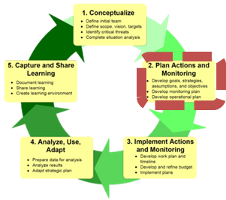
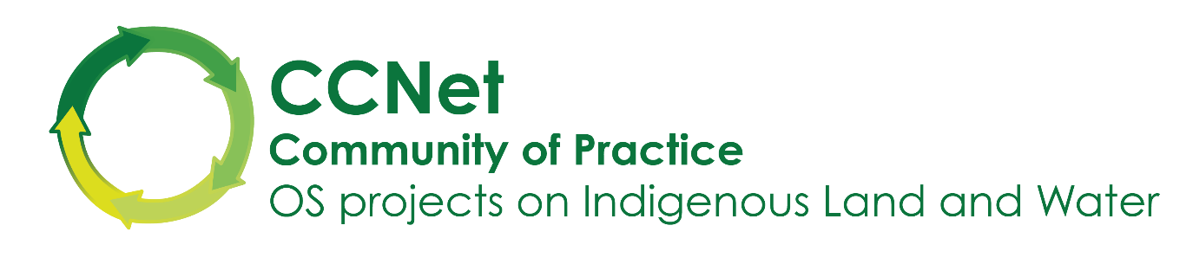Exercise: Result Chains

Summary: Each team will develop one Result Chain. Each team will select a priority strategy from the previous exercise. The team’s task is to develop a credible results chain for the strategy. Participants will get experience with why results chains are helpful and necessary when developing and implementing strategies, and for checking how their plan is going.

Instructions:
- Set yourself up with plenty of room. Make a ‘sheet’ for developing your roadmap by sticking together 2-3 sheets of flip chart paper. Overlap the sheets a little before you stick them together

- Choose a priority Strategy from the previous step

- “Bookend” the Result chain
  - On a sticky note (yellow), write the Strategy and stick it to the paper on the far left
  - On a green sticky note, write down one Target that the strategy is supposed to be helping and stick it to the paper on the far right (not near Trump).
  - Write the Goal for the Target on a light blue sticky note, and put it below the Target
  - If there is a Threat to the target, write that on a pink sticky note and put it on the left hand side of the target
  - Write the Threat Reduction Goal on a light blue sticky note underneath the Threat.

- Discuss the Activities that you will do to implement the strategy. These can be taken directly from the strategy descriptions developed in the previous session, or from your work plan if you have one already, or from your understanding as a group of what you have been doing.

- Write the Activities on smaller yellow sticky notes, and place them between the Strategy and the threat in order of the time they would happen – first thing first, then second etc.

- As a team, discuss the outcome you need to achieve to address your Threat and write a Threat Goal. Remember to make it SMART and to describe a change from Very High / High

- With the Strategy, Actions, and Goals in place (i.e., the bookends), “walk” from one end to the other:

  - If this is a familiar strategy that you know well, go from Left to Right in a series of “if-then” statements to the Goal (eg “if I see this result here, then I can move to this result” etc)
  - Write what you say for “then this is the result” on a dark blue sticky note. Use the actions to help you think of the results.

  - If this is an unfamiliar strategy that you do not know well, go from Right to Left in a series of “if-then” statements to the Strategy (eg “if I want to reach this result then this I need this result first”)
  - Write what you say for “then I need this result” on a sticky note. Use the actions to help you think of the steps.

- Every time you add a new step, go back and read aloud the series of if-then statements all the way through and see if anything is missing. By repeatedly going back to the beginning each time a new step is created, you will have a clear understanding of the strategy and its logic.

- After everyone has completed one results chain, we will pair up teams to review and edit the other results chain. One person from each team will describe the results chain to the review team. Reviewing teams should use the criteria for a good results chain (below) to evaluate and make suggestions for improvement. Write suggested changes on sticky notes for review later
CRITERIA FOR GOOD RESULTS CHAINS:
1. Results oriented: Boxes only contain desired results (e.g., reduction of hunting), and not activities (e.g., conduct a study).
2. Connected in a “causal” manner: There are clear connections of “if…then” between each pair of successive boxes.
3. Demonstrates change: Each box describes how you hope the relevant factor will change (e.g., improve, increase, or decrease).
4. Relatively complete: There are sufficient boxes to construct logical connections but not so many that the chain becomes overly complex.
5. Simple: There is only one result per box.

A general result chain will look something like this (but probably with more steps)

