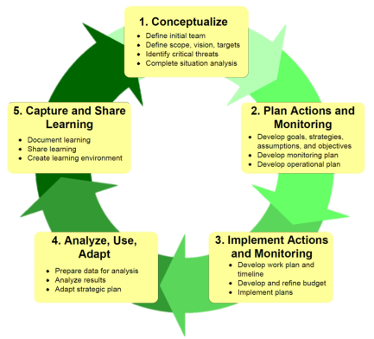Exercise: CLOSING THE LOOP: ANALYZE, REVIEW & ADAPT

Summary: Reviewing the success or otherwise of your plan is critical to the successful implementation of a plan over time. Knowing what worked and what did not provides critical information to help you adapt your strategies, and to achieve the plan’s vision. We want to make the next time Better, Cheaper, Faster
As well as learning ourselves, we want to encourage teams to share and learn from innovations to drive improvement in the practice of looking after our targets and caring for country.
To do this, as well as thinking about what has happened in the project, we need to reflect and improve outside the mechanics / routine of project.
To keep the plan alive and relevant, we also need to think about how you will work with your community and team to regularly review your plan and keep it working.
Task
Keeping your plan ‘alive’ is important for long-term success and it requires regular review and discussion, as well as regular updating.
You might need help from other people to do this, and resources to do it.
We are going to ‘practice’ plan review by looking back at the Pre-Plan work you did and adapting that ‘plan’ based on what you now know about the process.
In your team discuss and record what changes (if any) you need to make to the Pre-plan, and then revise that Pre-plan to make a new one.

