Mission, Vision, Goals and Accomplishments

What is the Conservation Coaches Network (CCNet)?
The Conservation Coaches Network is a network of peers - NGO partners and field based practitioners - who support the application of the Open Standards for the Practice of Conservation.

The mission of the Conservation Coaches Network is to catalyze transformational conservation by empowering people to develop, implement, evaluate, adapt and share effective strategies that achieve tangible conservation results benefitting people and nature all over the world.

Why a “Coaches Network?” In his latest book Blessed Unrest best-selling author Paul Hawken recognizes that a hopeful new movement is growing all over the world. This movement is springing up from the ground involving millions of people working to address the needs of their communities through local action. The Green Belt Movement in Kenya; the indigenous peoples movement in Australia to go back “on country”; the sustainable forestry efforts in rural British Columbia are just a few examples of the kinds of efforts Hawken describes that are engaging people in purposeful actions aimed at healing the wounds of the past and forging a more sustainable future. Hawken claims that this movement isn’t a top-down, centrally organized endeavor, but rather it is a spontaneous effort by millions of people in thousands of places to find solutions best suited to their home places.

He goes on to say that this movement is best supported not by top-down decisions but by helping participants identify and apply “useful problem-solving tools” to forge meaningful approaches that will work for them. This is at the heart of what the Conservation Coaches Network is all about. Conservation Coaches support people in their use and adaptation of a powerful approach to decision making, measuring and learning in ways that will be responsive to their needs. The aim of the Conservation Coaches Network is to provide an arena in which experiences and lessons learned from the thousands of efforts under way all around the world can then be shared.

What is CCNet’s long term vision? CCNet aims to have an engaged cadres of coaches (“franchises”) on every continent supporting people who are working to protect the most important places and solve the most challenging issues for their regions. The Network vision is that these franchises and coaches continuously improve and adapt the “Open Standards for the Practice of Conservation” framework in ways that are responsive to the cultures and communities in which they work and the unique conservation challenges they face. These franchises and coaches will be locally funded while being supported by a small network coordinating team who focuses on enhancing the skills and effectiveness of the coaches and providing opportunities for coaches to exchange and share promising practices and lessons learned real time across the greater Network. In this way, every team that needs support will have access to a trained coach who will help them plan, manage, monitor, and learn from their work, leading to meaningful conservation results all over the world.

What is CCNet’s progress to date (September 2012)?
- 420 Coaches
- Representing 57 countries, six continents and 82 different organizations
- Coaches supported more than 619 projects involving more than 600 organizations over the two-year period 2010-2011
- 12 formal franchises cover the United States, Canada, Europe, Africa, Australia, China, eastern Asia, Mesoamerica, South America, Pacific Islands & WWF Network.
- In Australia alone, every major federally funded corridor project is applying the Open Standards with the support of a Network Coach.
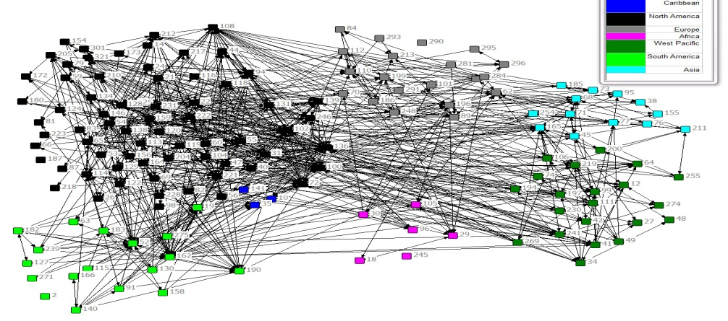
- Coaches are actively connecting with each other across continents, countries and organizations
Network Connections
Social Network map showing active exchanges occurring among 150 coaches from different continents. Each number represents a coach. The colors represent continents. Information from survey of coaches conducted summer, 2011.

What does the future look like?

Goals for FY2014:
- Hold new coach trainings in Australia, South and Meso America, Europe, and Central Africa.
- Translate new coach training materials into Spanish and French.
- Develop and implement a comprehensive communications and outreach plan to promote the Network.
- Launch a joint website with the Conservation Measures Partnership.
- Strengthen the skills of existing coaches and franchises by coordinating annual work plans and topical continuing educational webinars and providing for more new coaches mentoring and coach exchanges.
- Implement the new long-term funding strategy, including identifying and recruiting new Partner/Members for the Network.
“This process gave our people faith that they could stay connected to the land and a voice to express their vision for our land.”
- Terrah Guymala, Warddeken Indigenous Protected Area Chairman and CCNet Coach

