Protected Areas Learning and Research Collaboration
Open Standards Short Course

Exercise 1
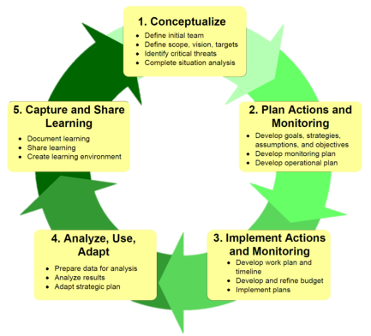
Step 1: Pre-planning (20 mins)
- Decide roles in your team using the Project Team ‘target’ as a guide
- Brainstorm the responses to the following questions. Write the answers on flip charts.
  - Why do we need a plan?
  - Who is the plan for?
  - Who else should be involved in the planning?
  - What will we produce at the end of the process – books, posters, videos etc?
Use the HCP Summary Card and planning table (overleaf) to guide some of your thinking.
Step 2: Scope / Vision (40 mins)
Determine starting Scope for your project
- Discuss possible scope
  - Four ‘scopes’ to consider – pick one or define your own
  - Property: Skullbone Plains/ trawtha mukaminya
  - Regional: Five Rivers area
  - Catchment: Nive River
  - Thematic: Sphagnum moss beds, Clarence galaxias
  - Other? - you decide
Draft an initial vision for the scope
- Imagine you are coming in to the region after an absence of 20 years
- You pick up a copy of the Mercury and there is an article about your region.
- What does it say:
  - Headline?
  - Main points?
  - Photos
- Write these down and then use them to decide a vision

Examples of Visions

Yangtze Basin - "A region where a living river links the Tibetan Plateau and the Pacific; where people thrive in harmony with nature, pandas play in the forests, children swim with dolphins and fish in the clear water, pheasants dance among the rhododendrons, and the cranes sing at sunrise. A region where natural cycles sustain a rich and ancient culture."

Kuuku Ya’u “By 2022, we the Kuuku Ya’u people will be proud and healthy, managing our own Ngaachi according to our strong customs and traditions.
Families will be living on Ngaachi and sit by the crystal clear rivers. The children are calling the plants, trees and animals by their language names and know the Stories about their Totems. Our Puuya will be filled with joy and our people will collect and eat plenty of fresh bush tucker. We can always come back anytime and there will be plenty of bush foods. We will fish and hunt in harmony within our Ngaachi guided by our seasonal knowledge.
Our rangers are fully equipped, qualified and employed to manage our sea, our land, our sacred and story places. We are the rightful protectors for our Ngaachi and our environment.
We will drive our vehicle with our outside friends as the passengers. We have respect for everything – the sea, the animals, culture, each other and our neighbours.”

Nantawarrina is a healthy place of peace with lots of animals and bushtucker that is looked after our (Nipapanha community) way. A place of respect, sharing of stories and learning knowledge between yura and udnyu, young and old people and families. A secure place that generates opportunities for the employment and wellbeing of the Nipapanha community.

Use this Table (or layout) to record your decisions in your Pre-Planning Stage

Step | Who | When | Preparation | Cost
Planning Stage | Specific people to be involved | Approx. time to complete | What needs to be done | Budget

