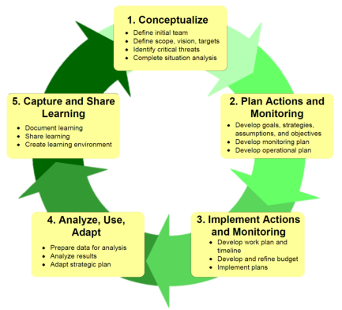Protected Areas Learning and Research Collaboration
Open Standards Short Course

Exercise: CLOSING THE LOOP: ANALYZE, REVIEW & ADAPT

Summary: Reviewing the success or otherwise of your plan is critical to the successful implementation of a plan over time. Knowing what worked and what did not provides critical information to help you adapt your strategies, and to achieve the plan’s vision. We want to make the next time Better, Cheaper, Faster
As well as learning ourselves, we want to encourage teams to share and learn from innovations to drive improvement in the practice of looking after our targets and caring for country.
To do this, as well as thinking about what has happened in the project, we need to reflect and improve outside the mechanics / routine of project.
To keep the plan alive and relevant, we also need to think about how you will work with your community and team to regularly review your plan and keep it working.

Task 1 (45 mins)
As a team, decide how to manage data for each level of monitoring and complete the table below. Assume that there is at least a 2 year gap between doing the monitoring and looking at the information. Also assume that different people are contributing, including community members.
  - Review the questions that monitoring is to answer in the three areas: Implementation (of actions), Effectiveness (of strategies) and Status (of target indicators)
  - Decide how the data that is gathered will be stored/retrieved and analysed.
  - Once we can get the information reliably, we then need to analyze and interpret it – decide what the analysis tells us about the original question.
  - The final step is to it ensure the people who need to know are told in an appropriate way and that the work plan or strategic plan is adapted based on the results of the interpretation.
 | Data capture / retrieval | Data Analysis | Adaptation
Implementation
Effectiveness
Status

Task 2 (30 mins)
Keeping your plan ‘alive’ is important for long-term success and it requires regular review and discussion, as well as regular updating.
You might need help from other people to do this, and resources to do it.
In your team discuss and record:
- How you will keep the process of review happening for your project
- How you will involve the community
- What resources you will need to do this.
- Develop a simple calendar showing the review cycle over the life of the plan (see example below)
