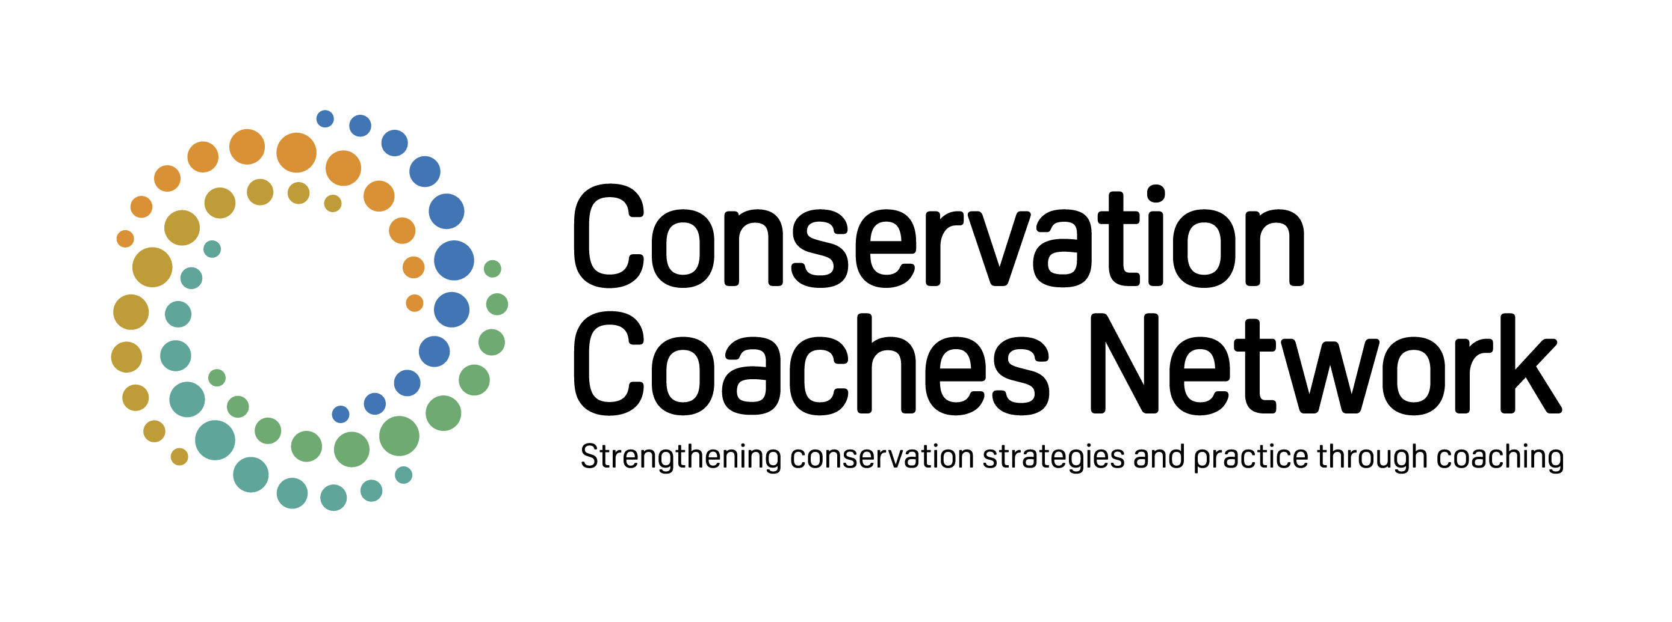

APPLICATION FORM:

CCNET COACH CERTIFICATION

Please be aware that in addition to submitting your application form there is a cost to apply for conservation coach certification, which covers a review of your application. Certification is not guaranteed and will depend on approval by the review committee. Note that this application may take considerable time to fill out – especially for the most experienced and qualified applicants.
Once completed, please save the file with your last name at the end and send your form with a cover letter to John Morrison (john.morrison@wwfus.org).
Name of Applicant:
Date of Application:
Current, Past Organisations:
E-mail address:

- EXPERIENCE

  - Please list any Open Standards or Open Standards Coaches Training taken (can include Coaches Rallies) – please add rows as necessary:
Open Standards Training Taken
Date | Location | Training Course/Session | Trainers’ Names

  - Please list experience with the application of the Open Standards, where you applied all or some elements of the OS (can include coaching others) – please add rows as necessary:

Open Standards Experience
Date | Organisation | Location | Project Programme Name  (including brief description of your role) | Project Attributes  (Biomes / themes)

1.3 Please list general conservation experience:

1.4 Please list any relevant special expertise (monitoring, facilitation, ecological knowledge, etc.):

1.5 List of at least 3 OS references (with emphasis on experienced coaches who have seen you at work as coach):
Open Standards References
Name (& email address) | Context

- SELF ASSESSMENT
2.1 Please fill out the self-assessment:
Self-Assessment Scoring Sheet (abbreviated skills)
 | Understand  (1 point) | Used Successfully  (2 points) | Confident Using  (3 points)
Facilitation
Demonstrates respect and sensitivity
Maintains role as facilitator
Designs & facilitates simple to moderate planning efforts
Provides opportunities for all participants to be involved
Understands the use of key probing questions
Quickly summarizes discussions and information
Provides and facilitates peer feedback
Conservation Knowledge
Gives appropriate examples of other sites & projects
Explains fundamental conservation biology principles
Describes basic ecology of relevant major habitat types
Assists teams to identify specific aspects of climate change
Cites examples of major conservation strategy types
Describes purposes & limitations of conservation tools
Open Standards
Clearly explains steps & rationale of Open Standards (OS)
Tailors OS process to meet the needs of projects
Ensures projects have a well-defined scope and vision
Ensures definition of measurable goals for ecosystems
Ensures a prioritized ranking of direct threats
Critically evaluates conceptual models
Coaches SMART viability & threat objectives
Ensures a set of prioritized strategies
Assists information management with Miradi or other
Theory of Change
Explains rationale for clear theory of change
Distinguishes results chain from flow chart
Identifies key intermediate results
Identifies key unspoken assumptions in strategies
Monitoring and Adaptive Management
Describes the purpose and value of monitoring
Coaches development of concise list of indicators
Describes common monitoring methods
Describes different levels of monitoring intensity
Describes activity, result, & biodiversity outcome measures
Describes key components of good monitoring protocol
Adaptive management & Reporting
Ensures process for routine analysis of project progress, results and assumptions
Describes process and standards for analysis, lessons-learned and decision-making
Describes standards & practices for information management & storage
Ensures compliance with various donor reporting requirements
Leads teams to analyze incoming project measures & adaptive planning
Operational Planning
Describes rationale & components of the work plan
Describes timeline development
Describes basic structure and framework of a budget
Describes general sources of funding/revenue
Describes how OS components fit into strategic plan
Meeting Planning
Clarifies meeting purpose, participation, funding, support team roles
Prepares agenda that meets objectives and cares for participants
Ensures appropriate venue and equipment
Ensures event is meeting objectives or adjusted as necessary
Digital Sharing & Collaboration
Shares documented experiences & lessons with community of practice
Actively participates Open Standards community of practice
Maintains a virtual coach profile on a CCNet website
Uses digital sharing & collaboration (WebEx, GoToMeeting, etc.)
Human Well-being Targets & Ecosystem Services
Describes human well-being targets & ecosystem services taxonomies
Assists to identify HWB targets, ES, & relation to conservation targets
Assists to integrate standard HWB & ES with stakeholder terminology
Assists to develop impact measures to assess HWB & ES
Advises on stakeholder engagement and participatory planning
Thematic Projects and Programs
Guides teams through designing non-placed based / thematic projects
Assists with appropriate conceptual models & results chains
Ensures connections of project interventions & conservation targets
Assists to design measures are appropriate to project thematic mandate
Climate Change and Climate Adaptation
Demonstrates understanding of causes & impacts of climate change
Demonstrates understanding of Open Standards climate guidance
Assists to identify existing applicable climate studies, modelling, analysis
Assists project teams to identify current and projected climate impacts
Assists to incorporate climate in conceptual models & threat ratings
Assists project teams to design climate-smart conservation strategies
Bonus: Environmental and Social Safeguards
Describes environmental & social safeguards & relevant donor policies
Assists to identify any potential negative short- and long-term impacts
Assists with Environmental/Social Mitigation/Monitoring Plans (ESMPs)
Assists to identify required assessments and consultations
Assists to identify potential positive social outcomes
Assists to integrate safeguards within project designs
  - Please describe any particular work product examples you would like to highlight:

- CERTIFICATION COST (USD)
To consider your application, CCNet will collect a fee through The Nature Conservancy, following this structure:

- Developed Countries: Application fee $300 (total) for three years, $150 (total) for three-year renewal.
- Developing Countries/Areas: Application fee $150 (total) for three years, $100 (total) for three-year renewal.

At renewal, applicants would need to show that they have made an effort to stay current with accepted practice (as identified in the self-assessment) and that they have been active as a coach.

Payments can be made here.

- WHAT IS NEXT?
You will get an e-mail acknowledging reception of your application and for reception of payment.

Once a full application form and payment have been received, the review committee will initiate reviews and will reach out in March-April 2021. Applicants can expect an announcement by approximately the end of May 2021.

If you have questions about the process, please contact CCNet's Global Coordinator, John Morrison (john.morrison@wwfus.org).

